Ex:No: 16

Date:

**HIGH LEVEL PROGRAMMING EXTENSIONS - PROCEDURES**

**Aim:**

To implement procedures using program in MySQL.

**PROCEDURES:**

A procedure is a subprogram that performs a specific action.

**Creating a procedure**

We use the CREATE PROCEDURE statement to create a new stored procedure. We specify the name of stored procedure after the CREATE PROCEDURE statement. The DELIMITER command is used to change the standard delimiter of MySQLcommands (i.e. ;). As the statements within the routines (functions, stored procedures or triggers) end with a semi-colon (;), to treat them as a compound statement we use DELIMITER.

Calling stored procedures(Executing a procedure)

In order to call a stored procedure, you use the following SQL command:

**CALL** stored_procedure_name();

**Problem 1:**

Create a simple procedure to get all the records from the table ‘student_info’.

**Problem 2:**

Create a stored procedure GetCustomerLevel() that accepts two parameters customer number and customer level.

* First, it gets the credit limit from the customers table.
* Then, based on the credit limit, it determines the customer level: PLATINUM, GOLD, and SILVER.
* The parameter p_customerlevel stores the level of the customer and is used by the calling program.

The following flowchart demonstrates the logic of determining customer level.

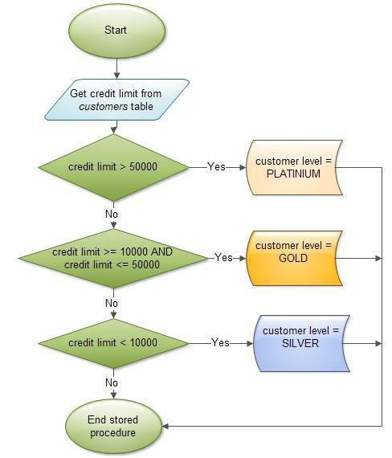

**Program-1:**

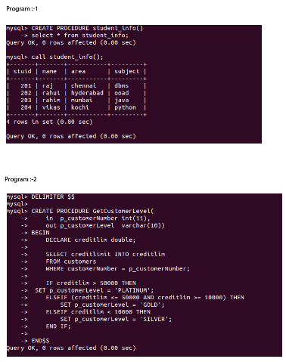

**Program-2:**



**RESULT:** Thus the high level procedures programs are executed successfully.